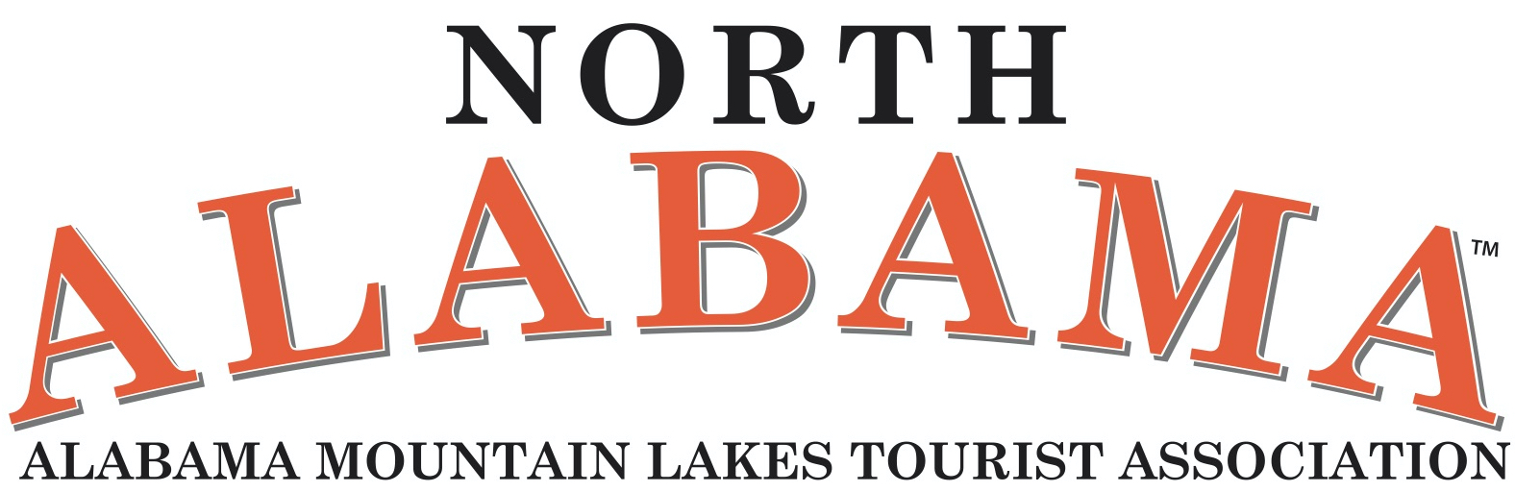

SCHOLARSHIP APPLICATION
FOR
SOUTHEAST TOURISM SOCIETY’S
2023 MARKETING COLLEGE

NAME:

ORGANIZATION:

POSITION:

ADDRESS:

PHONE: EMAIL:

ANNUAL BUDGET:

HOW MANY YEARS HAVE YOU WORKED IN THE TOURISM INDUSTRY?:

WOULD THIS BE YOUR: 1st Year 2nd Year 3rd Year Alumni

Staying in Dorm: Yes No

WHY WOULD YOU LIKE TO RECEIVE THIS SCHOLARSHIP?

______________________________________________________________________________
______________________________________________________________________________
______________________________________________________________________________
______________________________________________________________________________
______________________________________________________________________________
______________________________________________________________________________
______________________________________________________________________________
______________________________________________________________________________
______________________________________________________________________________

PLEASE SUBMIT YOUR APPLICATION TO: SCHOLARSHIP COMMITTEE, c/o AMLA, PO BOX 2537, Decatur, AL 35602 before August 31, 2023.

