AL House Economic Development and Tourism Committee Contact List 2023

 | Member of Committee | Phone | Address | Email
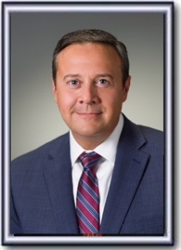 | Andy Whitt  (Chair) | (334) 261-0404 | 11 South Union Street  Suite 425  Montgomery AL 36130 | andy.whitt@alhouse.gov
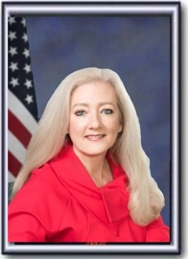 | Ginny Shaver  (Vice Chair) | (334) 261-0413 | 11 South Union Street  Suite 426  Montgomery AL 36130 | ginny.shaver@alhouse.gov
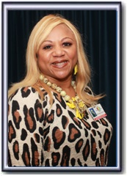 | Rolanda Hollis  (Ranking Minority Member) | (334) 261-9520 | 11 South Union Street  Suite 536-D  Montgomery AL 36130 | rolanda.hollis@alhouse.gov
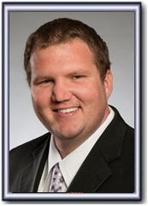 | Corey Harbison | (334) 261-0578 | 11 South Union Street  Suite 435  Montgomery AL 36130 | corey_harbison@yahoo.com
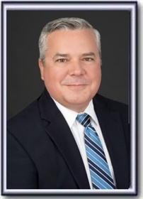 | Chip Brown | (334) 261-0447 | 11 South Union Street  Suite 524  Montgomery AL 36130 | chip.brown@alhouse.gov
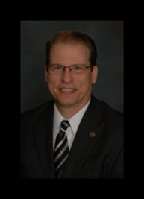 | Allen Treadaway | (334) 261-0585 | 11 South Union Street  Suite 417-G  Montgomery AL 36130 | allen.treadaway@alhouse.gov
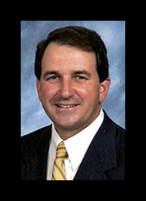 | Steve Clouse | (334) 261-0488 | 11 South Union Street  Suite 400-E  Montgomery AL 36130 | steve.clouse@alhouse.gov
 | Neil Rafferty | (334) 261-0543 | 11 South Union Street  Suite 532  Montgomery AL  36130 | reprafferty@gmail.com
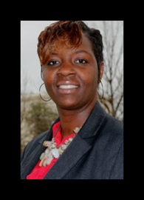 | TaShina Morris | (334) 261-0597 | 11 South Union Street  Suite 537-E  Montgomery AL 36130 | tashina.morris@alhouse.gov
 | Chad Robertson | (334) 261-0496 | 11 South Union Street  Suite 524-F  Montgomery AL 36130 | Chad.robertson@alhouse.gov
 | Frances Holk-Jones | (334) 261-0523 | 11 South Union Street  Suite 526-D  Montgomery AL 36130 | frances.holk-jones@alhouse.gov
 | Mikelann Auburtin (Clerk) | (334) 261-0488 |  | mikelann.auburtin@alhouse.gov
 | Daisy Goza (Executive Assistant/Scheduler, Speaker of the House) | (334) 261-0505 |  | daisy.goza@alhouse.gov

