FOR IMMEDIATE RELEASE
CONTACT: Alabama Mountain Lakes Tourist Association
PHONE: 256.350.3500 / 800.648.5381
EMAIL: info@northalabama.org
WITH ART

AMLA Holds First Certified Customer Service Training Program for the Hospitality Industry in North Alabama

Decatur, Ala. (October 1, 2021) – Frontline housekeeping, front desk personnel and sales coordinators in north Alabama’s hospitality industry will learn how to deliver exceptional customer service thanks to a new pilot program developed by the Alabama Mountain Lakes Tourist Association (AMLA).

AMLA, in partnership with Calhoun Community College, North Alabama Works, Yedla Management Company and Holistic Performance Group, has launched a customer service training program for frontline housekeeping, front desk personnel and sales coordinators in north Alabama’s hospitality industry. Fifteen employees completed the first training, Flawless Delivery, September 13-14, 2021, at the Courtyard by Marriott in Decatur, Ala. The two-day training program was facilitated by Holistic Performance Group based in Decatur, Ala.

Flawless Delivery, a customer service training program designed for frontline housekeeping, front desk personnel and sales coordinators, incorporates a strong foundation of empathy, communication and engagement in order to highlight the quality of service necessary to retain guests in today’s competitive environment. The training consists of 20 hours over the course of two days and one evening and uses gamification, small group projects, role play, team building exercises and lecture to engage participants. The co-training model incorporates bi-lingual trainers who are also skilled in differentiated learning practices.

In addition to the classroom learning, the training is an immersive experience, as the students become guests at a hotel and also serve as mystery shoppers. Two mystery shopper evaluations are submitted by the participants: One for the front desk, room and site experience, and one for the dining experience. These evaluations serve two functions. First, they enable the participants to comment based on their experience as guests, thus giving them a different perspective on the process. Second, the evaluations will help the host site by giving them valuable input on services received.

The two-day program concludes with a graduation ceremony where participants are presented with a certificate from Calhoun Community College and a Flawless Delivery Certified Pin.

AMLA President and CEO Tami Reist approached Calhoun Community College, Yedla Management Company and Holistic Performance Group with the idea to develop a certified training program for the hospitality industry. At this time, there are no trainings of this type available in the state of Alabama.

“One of my long term goals has been to establish a credited training program for the North Alabama hospitality industry,” said Reist. “Customer service expectations are at an all-time high and the Covid-19 pandemic has made it extremely difficult to find and retain good workers. This training is designed to equip frontline workers with the skills needed so they can communicate and engage with guests as well as with coworkers in order to deliver the quality of service the traveling public has come to expect.”

The Flawless Delivery certified customer service training program received an Existing Industry Training Program (EITP) grant from North Alabama Works and Calhoun Community College.
“Flawless Delivery provides training which can rejuvenate the hospitality industry and provide upward mobility for the participants. Calhoun Community College is pleased to partner with Yedla Management Group and Alabama Mountain Lakes Tourist Association to provide this unique and impactful training across our service region,” said Houston Blackwood, Director- Calhoun Workforce Solutions.

Employees who successfully complete the training will receive an incentive to continue employment in the field. One year after the end of the training, those participants who are still employed will receive a getaway for themselves and their families provided by AMLA. This will include a stay at an Alabama hotel, dining and recreation. They will be asked to again function as mystery shoppers thus helping hoteliers and entertainment venues with their input.

“The Yedla Team is proud to be a part of the Flawless Delivery customer service training pilot program. Through this training, we are investing in our employees and helping build a workforce that will continue to strengthen the north Alabama hospitality industry as we navigate the everchanging Covid-19 pandemic,” said Teresa W. Taylor, Yedla Management Company executive director of sales.

Yedla Management Company, headquartered in Big Spring Park in downtown Huntsville, provides hospitality management services for third party contracts, including all aspects of operations, sales and marketing, human resources and recruiting, engineering and accounting as well as short term hotel consultations for site selection, design and construction projects. The company currently has 21 properties located throughout Alabama, Tennessee, Florida, North Carolina, including 11 within north Alabama. Fifteen front-line employees and sales coordinators representing six of Yedla’s hotels located in Decatur and Huntsville participated in the pilot program.

“The Flawless Delivery training program will help to mitigate some of the training gaps in our employees who work most closely with the guests - front desk, housekeeping and sales coordinators,” added Taylor. “By mixing front desk, housekeeping and sales coordinators together in one training cohort, I believe it will help bridge the communication gaps that often exist between these three departments, all who play equally important roles in the hospitality industry.”

In addition to instructors from Holistic Performance Group, AMLA provided local industry leaders as guest speakers on important topics relevant to the “Flawless Delivery” approach to customer service development and to share personal experiences in the hospitality industry, adding an extra layer of support to the program. The two day training was also filmed in order to share with others in the industry who have the same training needs.

Reist will work with hotels and other members of the hospitality industry who are interested in bringing the training program to their company by offering assistance with the EITP grant application and support in executing the two day program. “With this training, AMLA is actively working with our membership to ensure our frontline employees are equipped with the skills and knowledge to be successful in their positions,” added Reist.

For more information on the Flawless Delivery training program, call Reist at 800-648-5381.

About Alabama Mountain Lakes Tourist Association (AMLA)
AMLA is a nonprofit organization dedicated to the promotion and development of the travel industry within the 16 northernmost counties of the state. It is supported by 500-plus members consisting of chambers of commerce, Convention & Visitors Bureaus, attractions, campgrounds, festivals, communities, counties, golf courses, restaurants, tour operators, accommodations, vendors, financial institutions and individuals. Counties included within the AMLA region are Blount, Cherokee, Colbert, Cullman, DeKalb, Etowah, Franklin, Jackson, Lauderdale, Lawrence, Limestone, Madison, Marion, Marshall, Morgan and Winston. Additional information on North Alabama destinations, accommodations and special events is available from the AMLA by calling 800.648.5381 or by visiting their web site at www.northalabama.org.

###

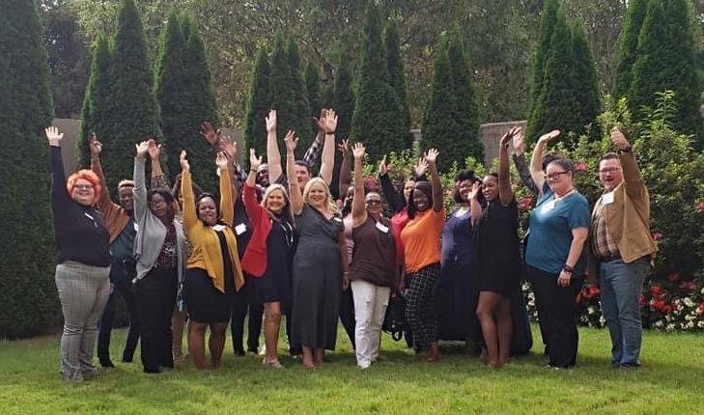

Photo caption: Fifteen front line workers from hotels located in Decatur and Huntsville completed the first Flawless Delivery customer service training program, September 13-14, 2021, held at the Courtyard by Marriott in Decatur, Ala.

Photo credit: AMLA

Flawless Delivery pilot program participants:

Courtyard Decatur:
Shae Newton – Guest Service Representative

DoubleTree Suites Huntsville South:
LaQuinten Washington – Night Auditor
Latrice Jones – Guest Service Representative
Cashmira Kuhn – Guest Service Representative
Jabria Finch – Front Office Supervisor
Rhonda Wheeler – Housekeeping Inspector

SpringHill Suites Huntsville Downtown:
Latashia Malone – Sales Coordinator
Latoria Pride – Guest Service Representative

Homewood Suites Huntsville Downtown:
LaCresha Wright – Guest Service Representative
Amecia Parker – Guest Service Representative

AC Hotel Huntsville Downtown:
Jacob Kirk – Sales Coordinator
Micheal Harper - Housekeeping Manager

Hampton Inn Arsenal / Huntsville
Jessica Bates – Front Desk Supervisor
Nikita Donaldson - Guest Service Representative
Shashana Sampson – Guest Service Representative

